Nuclear Radiation Detector

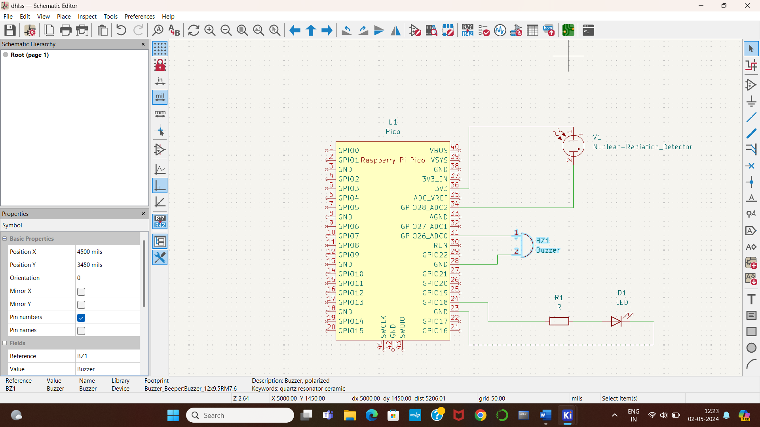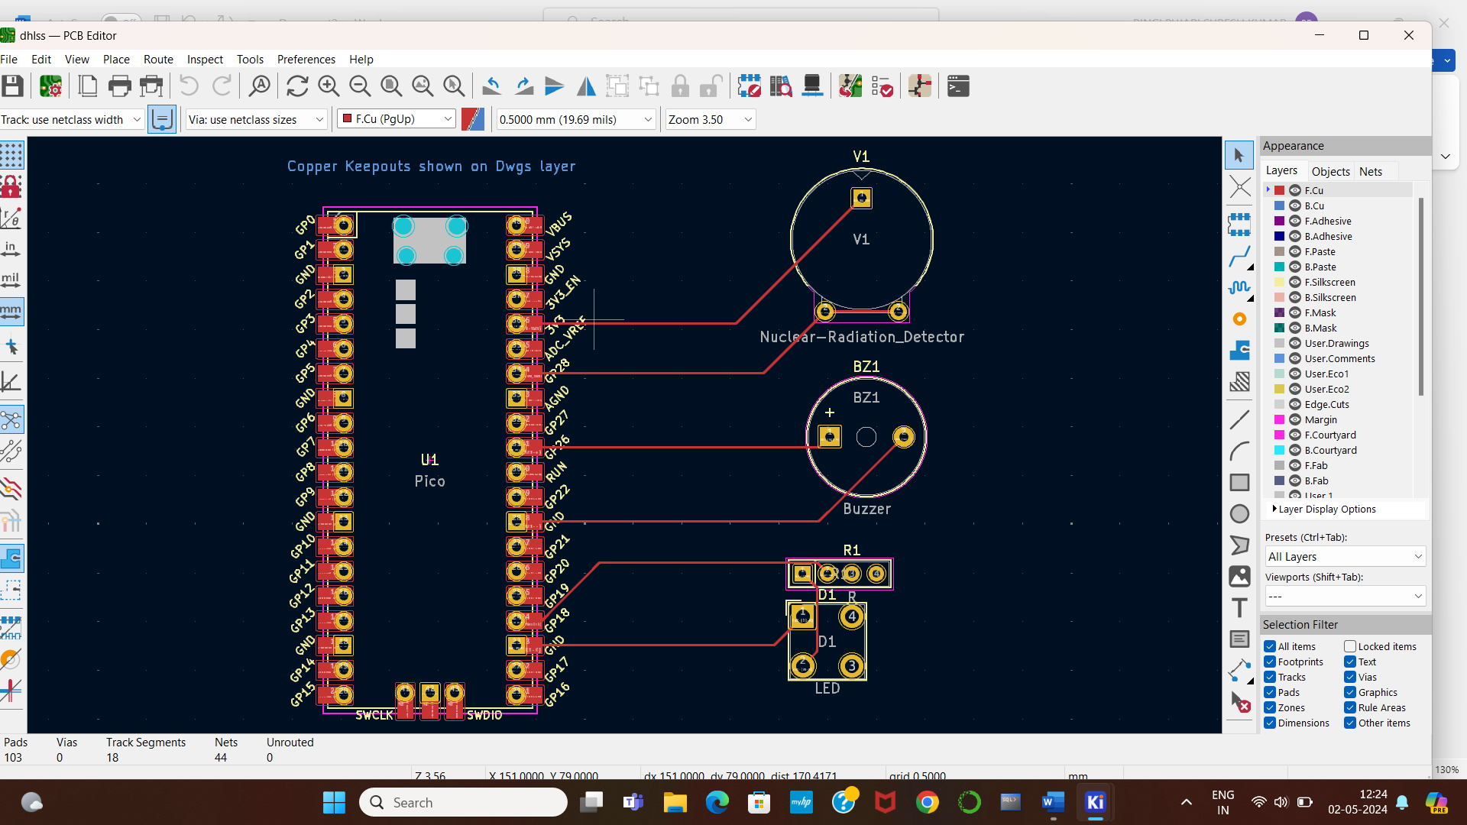

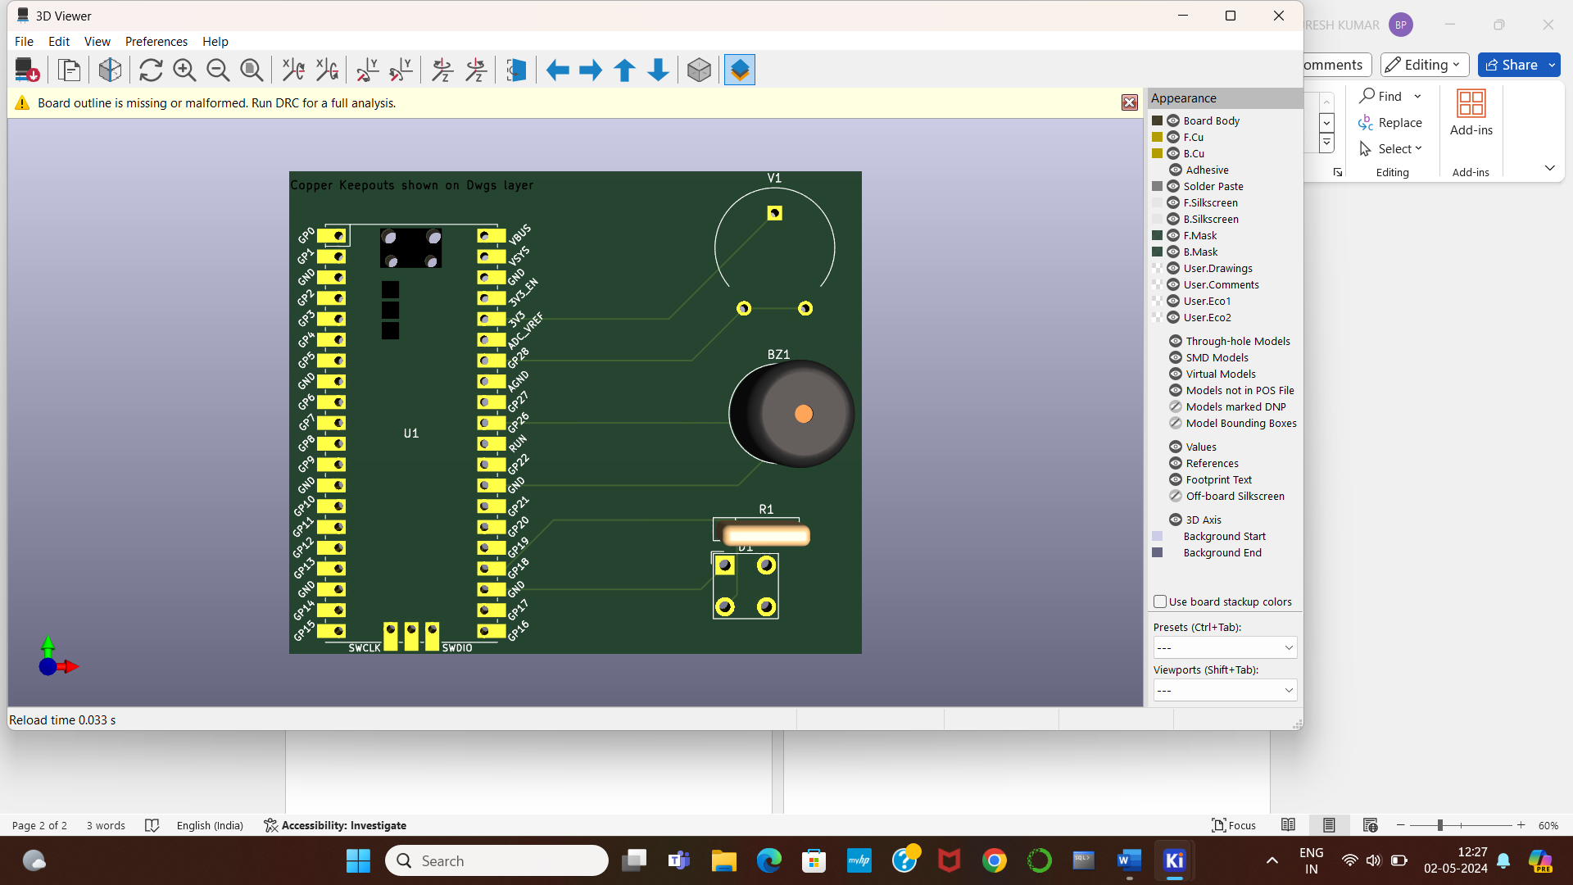

Roll No.

21781A04C7

21781A04E0

21781A04E8

21781A04F3

21781A04F4